5.84: Considering positive accelerations to be to the right (up and to the right for the left-hand block, down and to the right for the right-hand block), the forces along the inclines and the accelerations are related by where T is the tension in the cord and a the mutual magnitude of acceleration. Adding these relations, a) Since a comes out negative, the blocks will slide to the left; the 100-kg block will slide down. Of course, if coordinates had been chosen so that positive accelerations were to the left, a would be 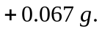 b) 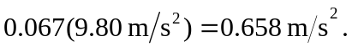
c) Substituting the value of a (including the proper sign, depending on choice of coordinates) into either of the above relations involving T yields 424 N.

